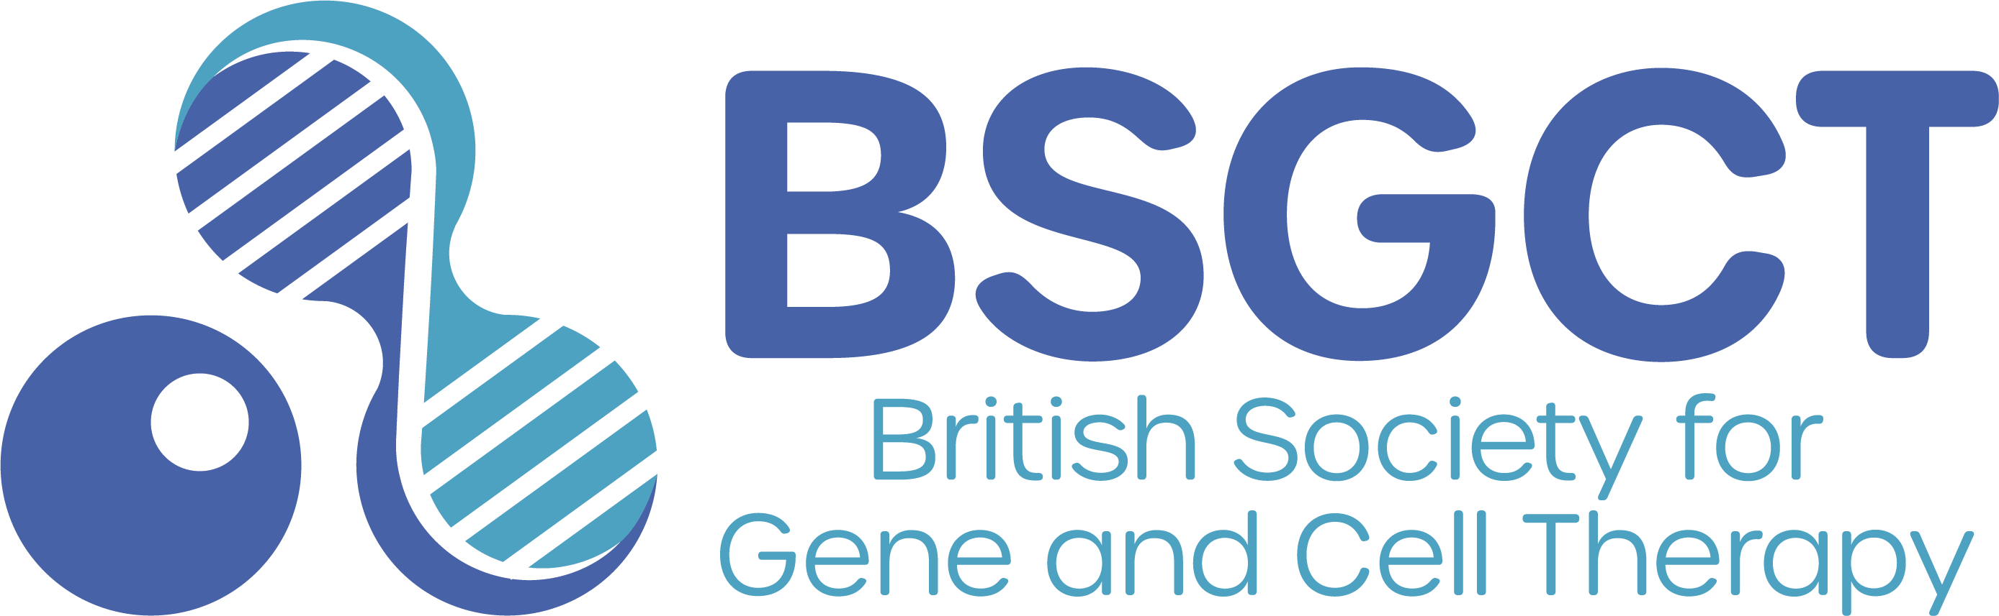
BSGCT Gene and Cell Therapy Day

Friday 13th March 2026
Oxford University Museum of Natural History
Welcome to the BSGCT Gene and Cell Therapy Day! As well as introducing gene and cell therapy, we’ll also be thinking about the ethical questions this work raises, and the impact it has on society and on you. Ask lots of questions, try out our hands-on activities, and chat with our (very friendly!) scientists.

Programme
Chair: Rajvinder Karda, University College London

09:45-10:10 | Arrival and registration
10:15-10:30 | Live polling
10:30-11:15 | The technologies, successes and challenges of the gene therapy revolution Simon Waddington, University College London
11:15-12:00 | From Message to Medicine: Using mRNA to Treat Disease  Sonam Gurung, UCL Great Ormond Street Institute of Child Health
12:00-13:30 | Lunchbreak  Exhibitors, hands-on activities, careers advice, meet the scientists
13:30-14:15 | How to Develop a Stem Cell Therapy  Ben Jevans, UCL Great Ormond Street Institute of Child Health
14:15-14:45 | SMA Type 1 - Life following gene therapy.  Dharmisha Stezaly
14:45-14:55 | 15 minute break
14:55-15:15 | Live polling and panel discussion
15:15-16:00 | Hands-on activities, careers advice, meet the scientists

